Aim of the project

A remote-controlled vehicle is any mobile machine controlled by means that are physically not connected with the origin external to the machine. In this project, we make use of Bluetooth technology to control our machine car. We do not call this a robot as this device does not have any sensors. Thereby, senseless robots are machines. The project aims are to design a Bluetooth control Arduino car and write a program into the Arduino microprocessor. Arduino car contains an Arduino microcontroller with basic mobility features. In this project, we make use of Bluetooth technology to control our machine car.

The use of the project

Bluetooth Control cars can be a helping hand for the cripples, or for the ones who want to drive but are unable due to many physical inabilities, where human life is at risk, we can use it from a very distance as it is fully wireless.

Project overview

Wireless control is one of the most important basic needs for all people all over the world. Bluetooth is one of the most used wireless technologies. A Bluetooth control car is such a car that can be controlled wirelessly using a Bluetooth control system and Arduino. With the combination of Arduino, and Bluetooth we can control many other things, like home Lighting, air conditioners, and many more through our cell phones. The Arduino can also contribute at

large to the Smart Home system. Nowadays it has made us easier to convert digital signals into physical movements with such microcontrollers.

Today people are using autonomation in every sector. There are many benefits, for example, it reduces the risk of injury, it is fast, it can work day long, it is reliable, etc. This Bluetooth control car is just an example of autonomation. This type of car is used in law enforcement and military engagements for some the reasons like Hazard exposure which is controlled from a location of

relative safety. Such vehicles are used by many police department bomb squads to defuse or detonate explosives. These vehicles are also used in space exploration, by using such vehicle NASA. ESA and ROSCOSMOS have explored and collected many data from space, the moon, and mars. In recent days giant companies are using remote control vehicles to deliver their products. And many of the giant factories have their transportation which is remotely controlled.

Here we have connected this 4-wheeler with Arduino and Bluetooth Module/ There is an Android application that is already installed in the remote device. We send our instruction to the vehicle with that application, that application is connected with the module in the vehicle.

Bluetooth module transfer that instruction as a signal to the Arduino, and Arduino works with that signal. In the Arduino, we have installed the code which can work with the signals and convert those instructions to the pre-defined signals. Signals were transferred to the motors, and the car started running.

This car does not have advanced features but we can attach any kind of features like line detecting, or obstacle detecting, even though we can attach the camera to the vehicle and watch it with the remote. This one is just a basic prototype of a remote-control car, we can add a lot of advanced features and get an armed/especially capable RC Car.

This project aimed to design an automated vehicle prototype built with Arduino and controlled with software developed on Android that can perform manual or automatic paths. Until now research and analyzing the simulation of experiments shown, it is believed that it is feasible touse the prototype designed for cognitive development, for future users can learn to insert custom paths that can process logic issues and more complex mathematics allowing the prototype to perform the desired movements. Analyzing the financial costs of design, it is believed that it is feasible to construct this type of prototype because it presents a low cost of the components used, particularly if they are chosen in a largescale production. It is worth noting that both the Arduino programming language and the language for Arduino in development are free, not burdening

additional costs for the development of the project, pointing out that this applies also to the tools used for development.

Methodology

Tools:

● Chassis (Including motors and wheels):

The main body of the car consists of the chassis. Alongside there will be four motors for

the four wheels which will lead down the car.

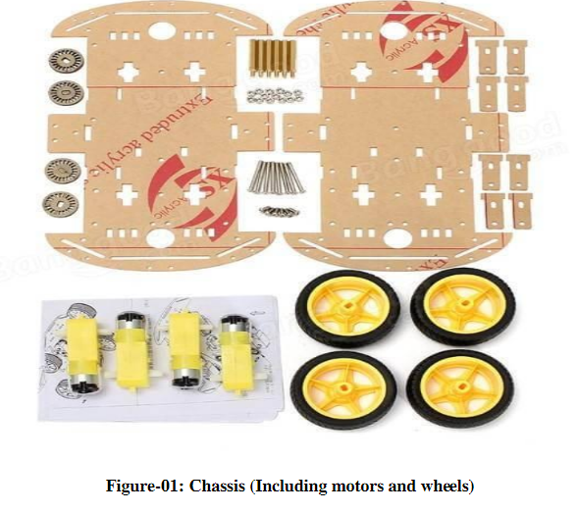

● Arduino Uno:

ARDUINO UNO

● Arduino Uno:

The Arduino Uno is an open-source microcontroller board based on the Microchip ATmega328P microcontroller and developed by Arduino. cc. The board is equipped with sets of digital and analog input/output pins that may be interfaced with various expansion

boards and other circuits.

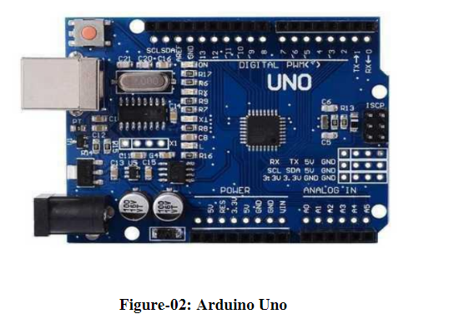

L293D Motor Drive H-Shield:

L293D Motor Drive H-Shield:

The Motor Driver is a module for motors that allows you to control the working speed and direction of two motors simultaneously. This Motor Driver is designed and developed based on L293D IC. L293D is a 16 Pin Motor Driver IC. This is designed to provide bidirectional drive currents at voltages from 5 V to 36 V. Rotation of a motor depends on the enabled pins.

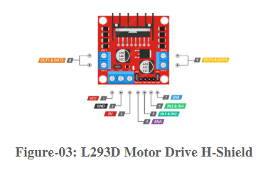

Jumper Wires:

Jumper Wires:

A jump wire (also known as jumper, jumper wire, DuPont wire) is an electrical wire, or group of them in a cable, with a connector or pin at each end (or sometimes without them components, without soldering.

– simply "tinned"), which is normally used to interconnect the components of a breadboard or other prototype or test circuit, internally or with other equipment or

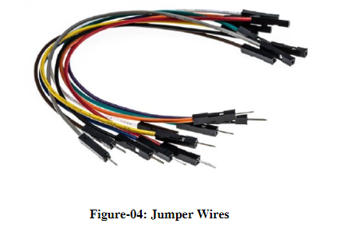

Battery:

● Battery:

A battery is an energy source consisting of one or more electrochemical cells and terminals on both ends called an anode (-) and a cathode (+). Here for the project, a 9V battery has been used.

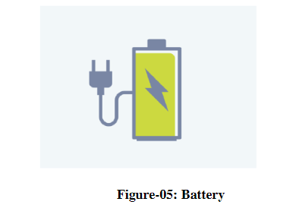

Bluetooth Module:

Bluetooth Module:

In figure 7 HC-05 6 Pin Wireless Serial Bluetooth Module is a Bluetooth module for use with any microcontroller. It uses the UART protocol to make it easy to send and receive data wirelessly. The HC-06 module is a slave-only device. This means that it can connect to most phones and computers using Bluetooth technology.

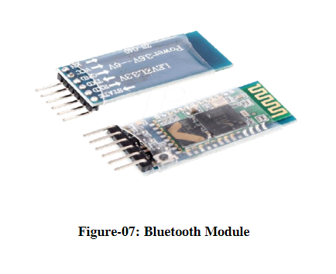

Pin diagram and circuit connection

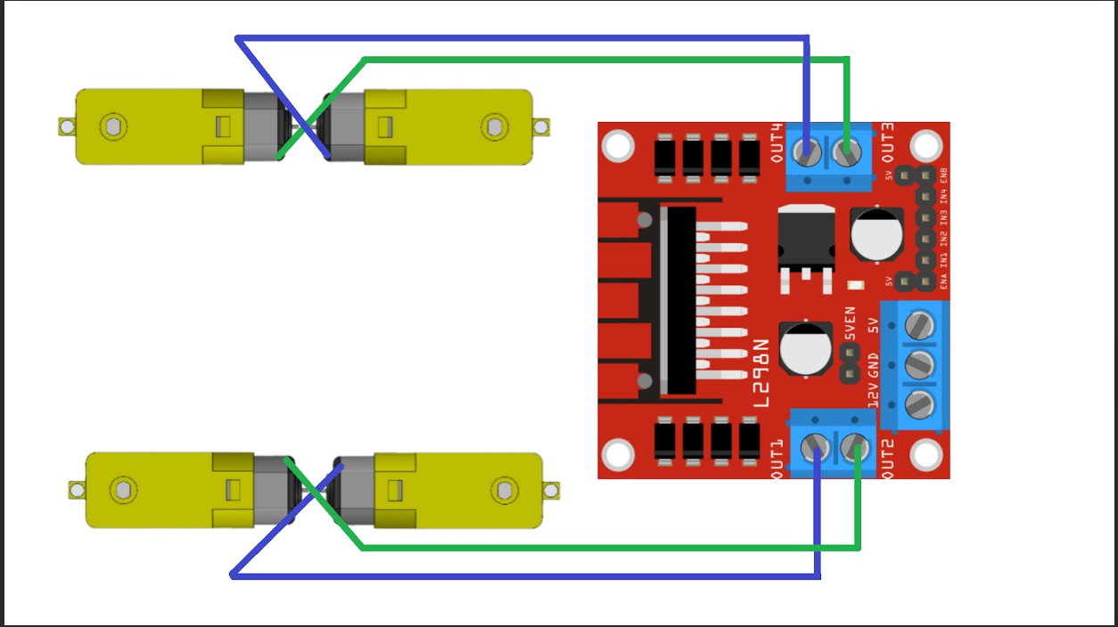

Fig 1: Connection of the motors to the motor driver.

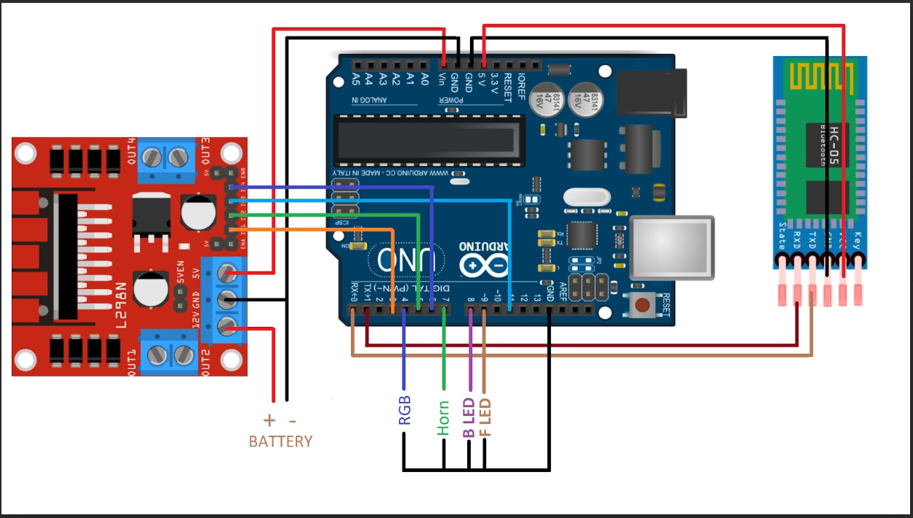

Fig 2: Connection of the circuit(Arduino ,Bluetooth module and Motor Driver)

Source code:

char t;

void setup() {

pinMode(9,OUTPUT);   //left motors forward

pinMode(10,OUTPUT);   //left motors reverse

pinMode(11,OUTPUT);   //right motors forward

pinMode(12,OUTPUT);   //right motors reverse

Serial.begin(9600);

}

void loop() {

if(Serial.available()){

  t = Serial.read();

  Serial.println(t);

}

if(t == '1'){            //move forward(all motors rotate in forward direction)

  digitalWrite(9,HIGH);

  digitalWrite(10,LOW);

  digitalWrite(11,HIGH);

  digitalWrite(12,LOW);

}

else if(t == '2'){      //move reverse (all motors rotate in reverse direction)

  digitalWrite(9,LOW);

  digitalWrite(10,HIGH);

  digitalWrite(11,LOW);

  digitalWrite(12,HIGH);

}

else if(t == '3'){      //turn right (left side motors rotate in forward direction, right side motors doesn't rotate)

  digitalWrite(9,LOW);

  digitalWrite(10,LOW);

  digitalWrite(11,HIGH);

  digitalWrite(12,LOW);

}

else if(t == '4'){      //turn left (right side motors rotate in forward direction, left side motors doesn't rotate)

  digitalWrite(9,HIGH);

  digitalWrite(10,LOW);

  digitalWrite(11,LOW);

  digitalWrite(12,LOW);

}

else if(t == '5'){      //STOP (all motors stop)

  digitalWrite(9,LOW);

  digitalWrite(10,LOW);

  digitalWrite(11,LOW);

  digitalWrite(12,LOW);

}

t=' ';

delay(100);

}

Conclusion

This project consists of a basic prototype of a Bluetooth control car above stated. The prototype car can recognize commands from users and can turn the car left, right, and stop with great accuracy. It can be further improved by using different sensors like ultrasonic or infrared and with various levels of coding.

Our Bluetooth control car has a range of 10-20 meter with the mobile Bluetooth controlling system. The range mostly depends on the receivers transmission level.

In the future, we could use rechargeable batteries like Ni-Cd Battery or Li-ion batteries that could avoid the present disadvantage. Also, we could make use of this RC Motor Car as a surveillance system or rovers by adding a few more sensors and updating the code. This would make them into robots. These robots could self-monitor under any human supervision, thereby reducing manpower. These are just the alternatives, on which this project could be improvised

and updated. IoT or the internet of things is a very important part of both computers and our daily lives. The above model describes how the Arduino programs the car motor module and by IoT, we rotate the wheels and give direction to the car. IoT allows us to work with different platforms and it

helps us to create various interesting modules to work on.

With the ever-increasing problems, our knowledge has to expand to adapt better to the changes all around us. In the same way, it is hoped that this activity is a small step that would lead us to further enhancements and goals.